SEO Report

SEO Report Subtitle
Company Name
1234 Main St. City, State 12345
123-456-7890
example@company.org
example.org

Table of Contents
Table of Contents
SEO Report 1
SEO Report Subtitle 1
Table of Contents 2
Local SEO Audit 1 5
Back SEO Marketing Software 5
Node Distance: 1 5
Local SEO Audit 15 8
Back SEO Marketing Software 8
Node Distance: 15 8
Search Audit 13
Search Audit 20
Website Content Audit 23
ppc - BackSEO 25
https://backseo.org/tag/ppc/ 25
Getting Started - BackSEO 26
https://backseo.org/getting-started/ 26
Learn Marketing - BackSEO 27
https://backseo.org/category/learn/ 27
Checkout - BackSEO 28
https://backseo.org/checkout/ 28
Downloads - BackSEO 29
https://backseo.org/downloads/ 29
writing clients - BackSEO 30
https://backseo.org/tag/writing-clients/ 30
Receipt - BackSEO 31
https://backseo.org/checkout/receipt/ 31
How to create a theme in Back SEO - BackSEO 32
https://backseo.org/how-to-create-a-theme-in-back-seo/ 32
Back SEO Content Editor - BackSEO 33
https://backseo.org/tag/back-seo-content-editor/ 33
Login - BackSEO 34
https://backseo.org/login/ 34
How The Back SEO content editor boosts rankings (All the way to #1) - BackSEO 35
https://backseo.org/back-seo-content-editor/ 35
Confirm Purchase - BackSEO 36
https://backseo.org/downloads/backseo-content-tool/ 36
building authority - BackSEO 37
https://backseo.org/tag/building-authority/ 37
Features - BackSEO 38
https://backseo.org/features/ 38
Contact - BackSEO 39
https://backseo.org/contact-2/ 39
Privacy Policy and terms of service - BackSEO 40
https://backseo.org/privacy-policy/ 40
5 Strategies to Write SEO Content that Dominates the Competition - BackSEO 41
https://backseo.org/5-strategies-to-write-seo-content/ 41
Be an Organized Writer – 5 Awesome ways Back SEO Can Help - BackSEO 42
https://backseo.org/be-an-organized-writer-with-back-seo/ 42
featured product - BackSEO 43
https://backseo.org/tag/featured-product/ 43
Order History - BackSEO 44
https://backseo.org/checkout/order-history/ 44
writing - BackSEO 45
https://backseo.org/tag/writing/ 45
Maximizing Your SEO Agency’s Success: Targeting the Right Market with Authority - BackSEO 46
https://backseo.org/maximizing-seo-agency-success/ 46
keyword tool - BackSEO 47
https://backseo.org/tag/keyword-tool/ 47
idea generator - BackSEO 48
https://backseo.org/tag/idea-generator/ 48
Back SEO Content Editor Training - BackSEO 49
https://backseo.org/category/back-seo-training/ 49
Boost Productivity with these 7 Detailed Features in Back SEO - BackSEO 50
https://backseo.org/7-ways-content-editors-boost-productivity/ 50
5 Rules to Building Authority in a Local Community - BackSEO 51
https://backseo.org/5-rules-to-building-authority-in-a-local-community/ 51
Maximizing SEO Potential: A Comprehensive Guide to Crafting an Exceptional Article - BackSEO 52
https://backseo.org/maximizing-seo-potential-a-comprehensive-guide-to-crafting-an-exceptional-article/ 52
SEO - BackSEO 53
https://backseo.org/category/seo/ 53
Transaction Failed - BackSEO 54
https://backseo.org/checkout/transaction-failed/ 54
Understanding the 15 Essentials of SEO – beginner to master - BackSEO 55
https://backseo.org/understanding-the-essentials-of-seo/ 55
Comparison - BackSEO 56
https://backseo.org/tag/comparison/ 56
Updates - BackSEO 57
https://backseo.org/updates/ 57
seo writing - BackSEO 58
https://backseo.org/tag/seo-writing/ 58
write seo content - BackSEO 59
https://backseo.org/tag/write-seo-content/ 59
Using the Back SEO Instruct AI Comparsler - BackSEO 60
https://backseo.org/using-the-back-seo-instruct-ai-comparsler/ 60
Home - BackSEO 61
https://backseo.org/ 61
Back SEO Agencies - BackSEO 62
https://backseo.org/downloads/back-seo-agencies/ 62
seo agency - BackSEO 63
https://backseo.org/tag/seo-agency/ 63
Google Keyword Tool Lacking? Get 100s instantly with Back SEO - BackSEO 64
https://backseo.org/google-keyword-tool-lacking-get-100s-instantly-with-back-seo/ 64
Blog - BackSEO 65
https://backseo.org/blog/ 65
About - BackSEO 66
https://backseo.org/about/ 66
community - BackSEO 67
https://backseo.org/tag/community/ 67
Agencies - BackSEO 68
https://backseo.org/agencies/ 68
Themes - BackSEO 69
https://backseo.org/themes/ 69
local seo - BackSEO 70
https://backseo.org/tag/local-seo/ 70
Sitemap - BackSEO 71
https://backseo.org/sitemap/ 71
Confirmation - BackSEO 72
https://backseo.org/checkout/confirmation/ 72

Local SEO Audit 1
Back SEO Marketing Software

Back SEO Marketing Software

Node Distance: 1
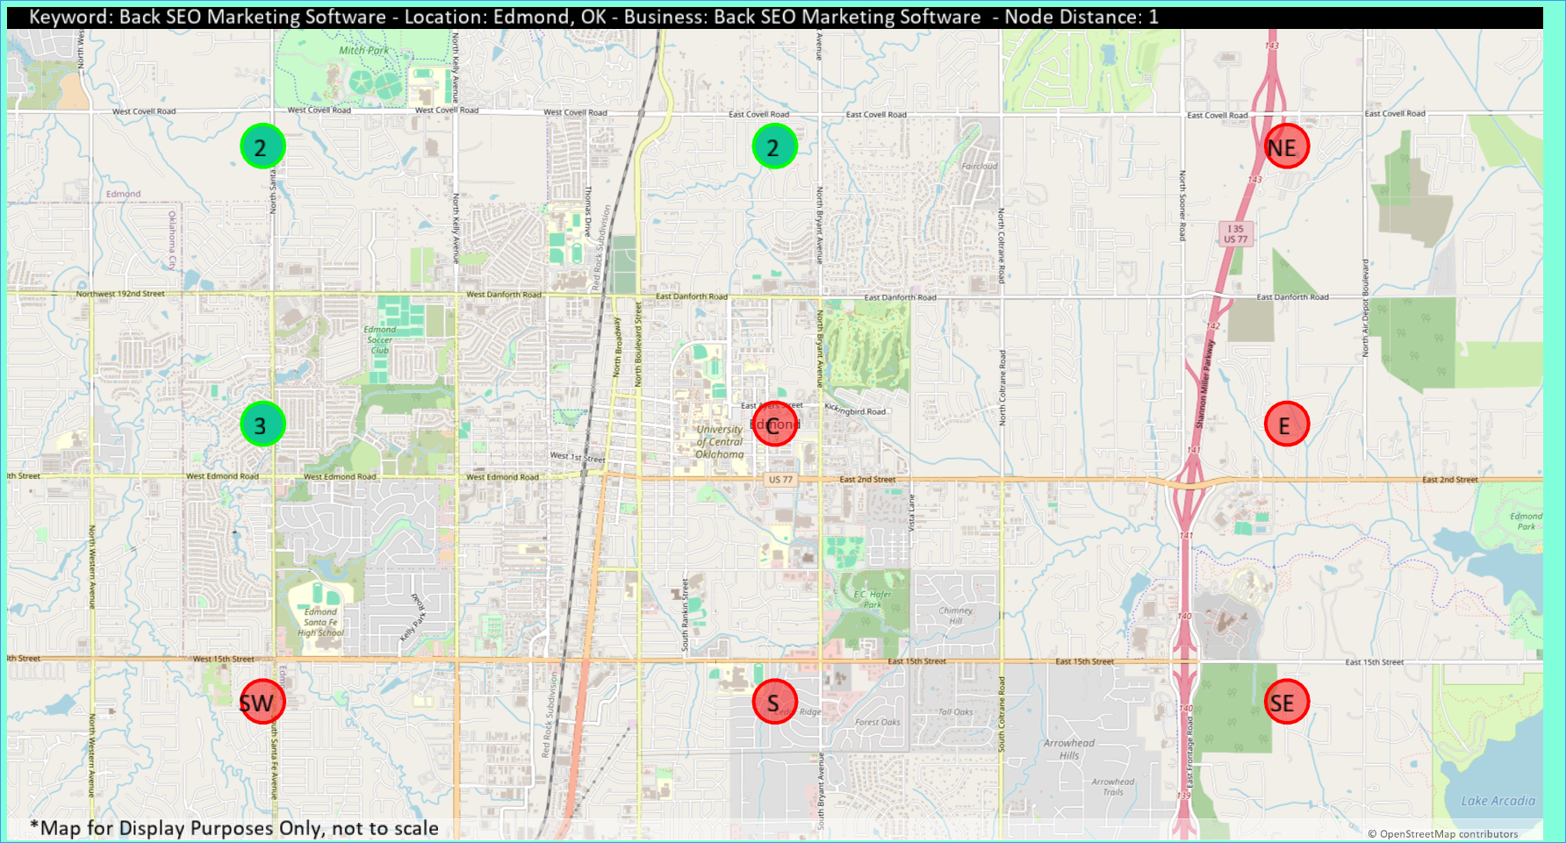
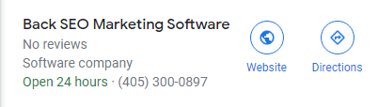
Direction | Rank 1 | Rank 2 | Rank 3
NW | 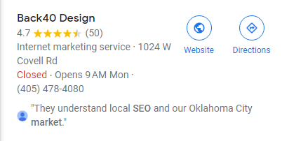 |  | 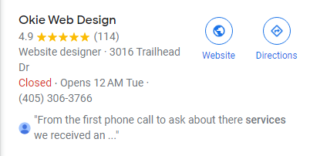
N
NE
W | 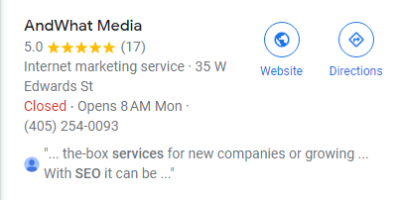
C
E
SW
S
SE

NW | Competitor | Google Card
Rank 1 | Back40 Design
Rank 2 | Back SEO Marketing Software

N | Competitor | Google Card
Rank 1 | Back40 Design
Rank 2 | Back SEO Marketing Software

W | Competitor | Google Card
Rank 1 | AndWhat Media
Rank 2 | Back40 Design
Rank 3 | Back SEO Marketing Software

Local SEO Audit 15
Back SEO Marketing Software

Back SEO Marketing Software

Node Distance: 15
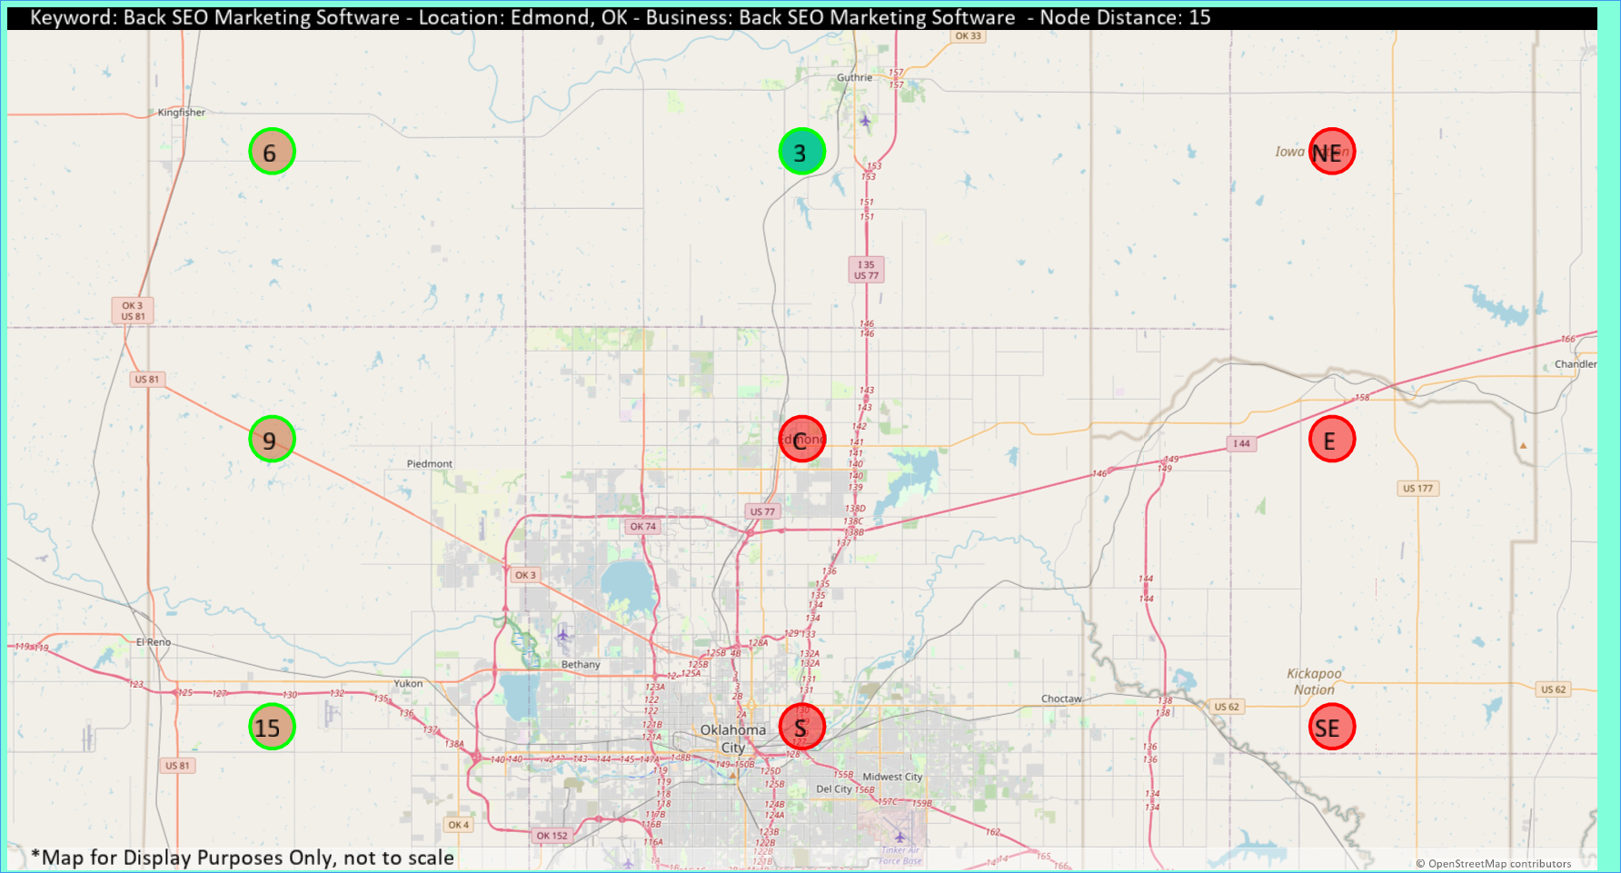
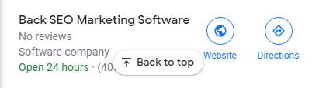
Direction | Rank 1 | Rank 2 | Rank 3
NW | 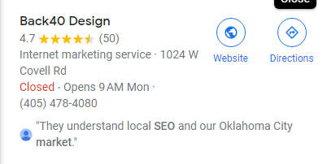 |  | 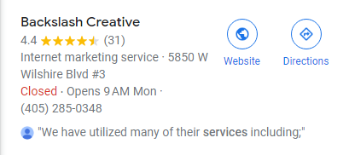
N
NE
W |  |  | 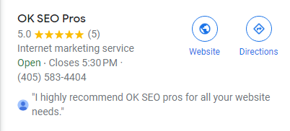
C
E
SW |  | 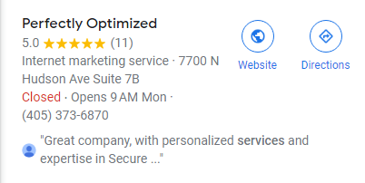 | 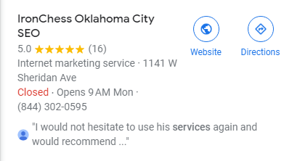
S | 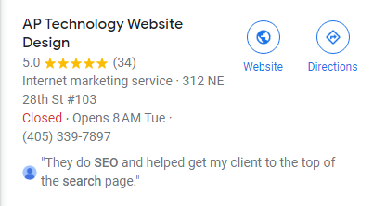 | 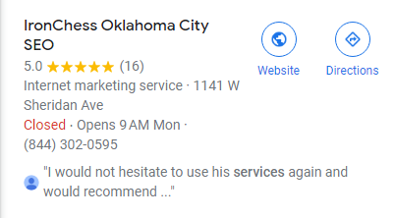 | 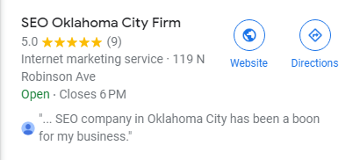
SE

NW | Competitor | Google Card
Rank 1 | Back40 Design
Rank 2 | Okie Web Design
Rank 3 | Backslash Creative
Rank 4 | OK SEO Pros | 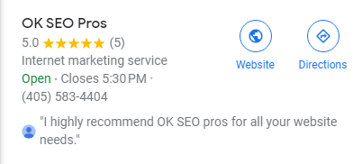
Rank 5 | AP Technology Website Design | 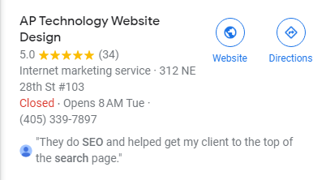
Rank 6 | Back SEO Marketing Software | 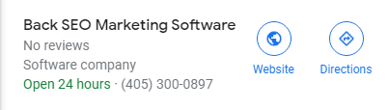

N | Competitor | Google Card
Rank 1 | Back40 Design
Rank 2 | Okie Web Design
Rank 3 | Back SEO Marketing Software

W | Competitor | Google Card
Rank 1 | Backslash Creative
Rank 2 | Back40 Design
Rank 3 | OK SEO Pros
Rank 4 | Big Think Web Creative | 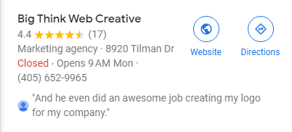
Rank 5 | Perfectly Optimized | 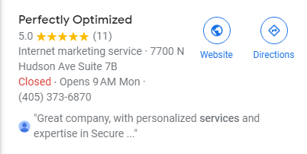
Rank 6 | Digital Web Geeks Oklahoma City | 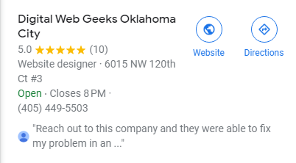
Rank 7 | Optimized Zen | 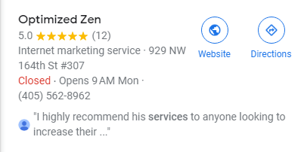
Rank 8 | Outpace SEO | 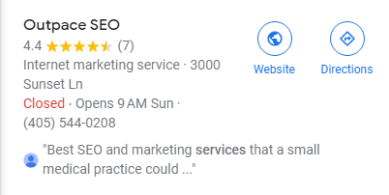
Rank 9 | Back SEO Marketing Software | 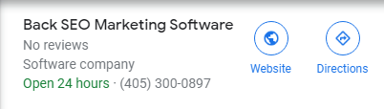

SW | Competitor | Google Card
Rank 1 | Backslash Creative
Rank 2 | Perfectly Optimized
Rank 3 | IronChess Oklahoma City SEO
Rank 4 | The SEO Answer | 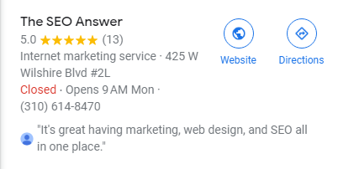
Rank 5 | Optimized Zen
Rank 6 | SEO Oklahoma City Firm
Rank 7 | Oklahoma Web Design Hosting | 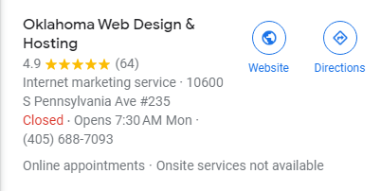
Rank 8 | Big Think Web Creative
Rank 9 | Bricktown SEO | 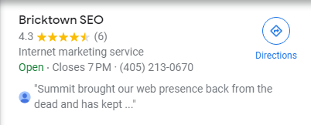
Rank 10 | Digital Web Geeks Oklahoma City | 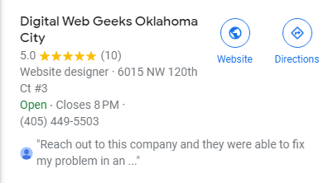
Rank 11 | Directing Design, Inc | 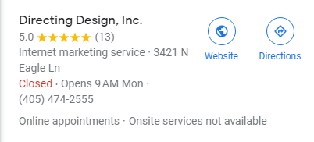
Rank 12 | Front2Back Studio | 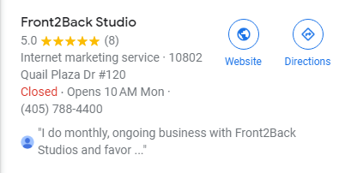
Rank 13 | OK SEO Pros | 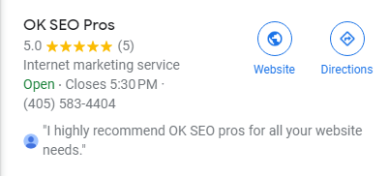
Rank 14 | Fylo | 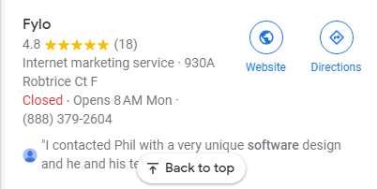
Rank 15 | Back SEO Marketing Software

Search Audit
Back SEO Marketing Software
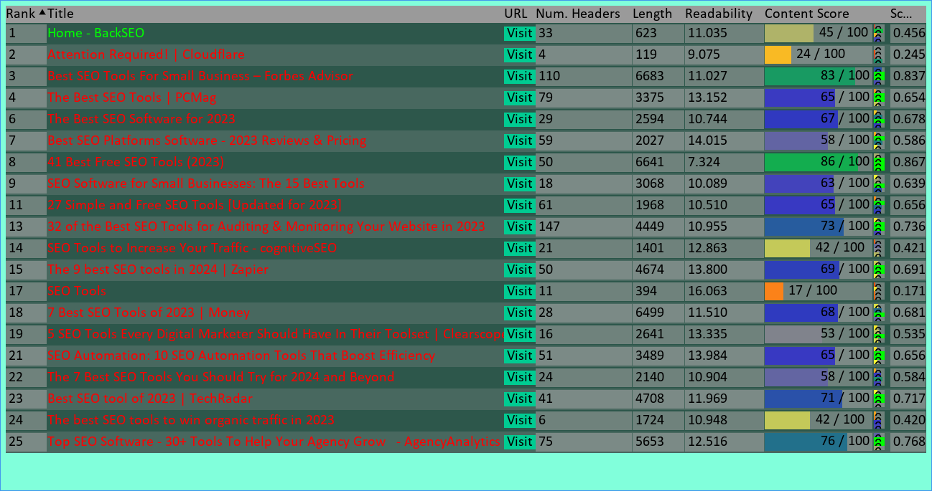

Keyword | Avg. # of Occurences
search engines | 4.454545454545454
search results | 4.0
screaming frog | 4.75
schema markup | 3.5
free version | 3.7142857142857144
seo campaigns | 3.0
yoast seo | 3.0
google analytics | 4.444444444444445
backlink profile | 2.0
web pages | 4.333333333333333
seo tools | 11.9375
keyword research | 7.0
marketing software | 4.0
google search console | 5.3
content marketing | 4.0
social media | 3.0
seo efforts | 2.6666666666666665
rank tracking | 4.0
seo tool | 25.75
seo spider | 5.0
moz pro | 6.666666666666667
paid version | 3.0
free trial | 10.2
keyword research tool | 5.0
keyword tool | 3.0
free seo tools | 4.333333333333333
day trial | 4.8
search volume | 3.75
broken links | 3.0
seo software | 6.555555555555555
backlink analysis | 2.6
web page | 3.3333333333333335
organic traffic | 2.2
competitor research | 2.5
link building | 5.0
search console | 6.0
seo strategy | 3.75
se ranking | 4.0
google trends | 4.5
screaming frog seo spider | 2.0
user experience | 2.0
google ads | 2.5
free tool | 4.666666666666667
duplicate content | 6.0
free account | 4.0
free tools | 3.0
keyword difficulty | 3.0
chrome extension | 4.0
bing webmaster tools | 3.0
specific keyword | 2.0
structured data | 2.0
search engine | 14.0
local seo | 10.5
learning curve | 11.0
customer support | 7.0
day free trial | 5.0
competitor analysis | 4.0
seo services | 3.0
premium plan | 4.0
pro plan | 4.0
site audits | 2.6666666666666665
page speed | 3.5
live chat | 2.0
digital marketing | 4.666666666666667
technical seo | 4.25
search engine optimization | 2.6666666666666665
landing pages | 2.0
seo audit | 2.5
seo metrics | 2.5
website content | 7.0
content optimization | 8.0
target audience | 2.5
content plan | 3.0
target keyword | 5.0
organic search | 3.3333333333333335
seo toolkit | 2.0
marketing tools | 2.0
search terms | 2.0
seo pro | 5.0
seo professional | 2.5
keyword magic tool | 10.0
small businesses | 9.0
target keywords | 9.0
site audit | 7.5
seo campaign | 6.5
seo writing assistant | 7.0
google search | 6.0
keyword rankings | 4.0
position tracking | 3.0
seo performance | 3.0
google account | 2.0
data sources | 2.0
billed annually | 6.0
competitive analysis | 2.5
seo data | 2.0
customizable reports | 2.0
seo platforms | 2.0
seo agency | 15.0
rank tracker | 11.0
marketing agencies | 5.0
search engine rankings | 4.0
seo strategies | 4.0
google keyword planner | 4.0
search term | 3.0
customer service | 3.0
looker studio | 3.0
tool lets | 3.0
relevant keywords | 2.0
meta descriptions | 2.0
great tool | 2.0
rank tracking tool | 2.0
content creation | 7.0
blog post | 6.0
all-in-one seo tool | 3.0
related keywords | 2.0
keyword research tools | 2.0
wide range | 2.0
all-in-one platforms | 2.0
ranking tool | 2.0

Search Audit
Back SEO Marketing Software in Edmond, OK
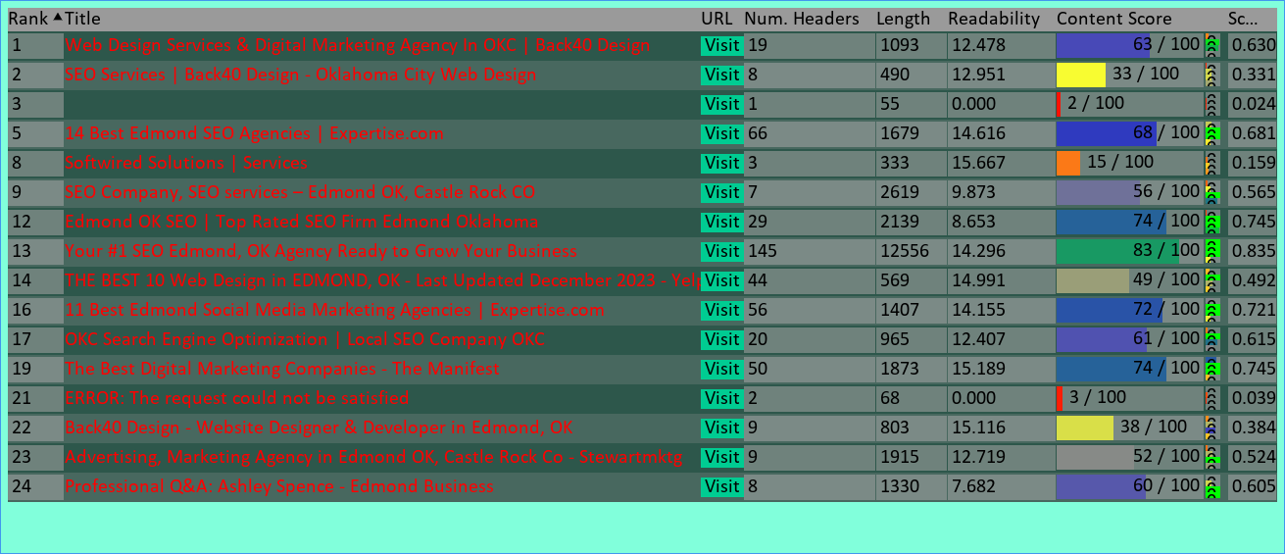

Keyword | Avg. # of Occurences
digital marketing | 14.5
oklahoma city | 19.0
surrounding areas | 2.0
social media | 6.0
search engines | 2.3333333333333335
web design | 30.0
search engine optimization | 8.75
graphic design | 6.25
local seo | 6.0
online marketing | 5.0
digital marketing agency | 4.0
social media marketing | 13.0
social media marketing services | 3.0
seo company | 2.0
web design agency | 2.0
castle rock | 8.0
marketing products | 2.0
seo agency | 5.0
content creation | 3.0
content journey | 3.0
social media management | 3.0
liquid media | 3.0
small businesses | 3.0
lighthouse web design | 2.0

Website Content Audit
backseo.org
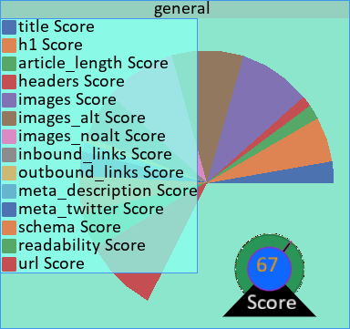 | 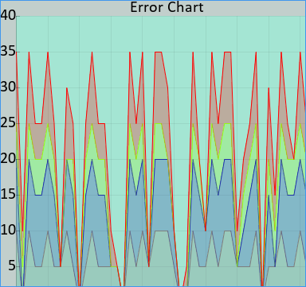
55 Critical Errors Found.
34 Moderate Errors Found.
69 Minor Errors Found.
59 Suggestions Recommended.
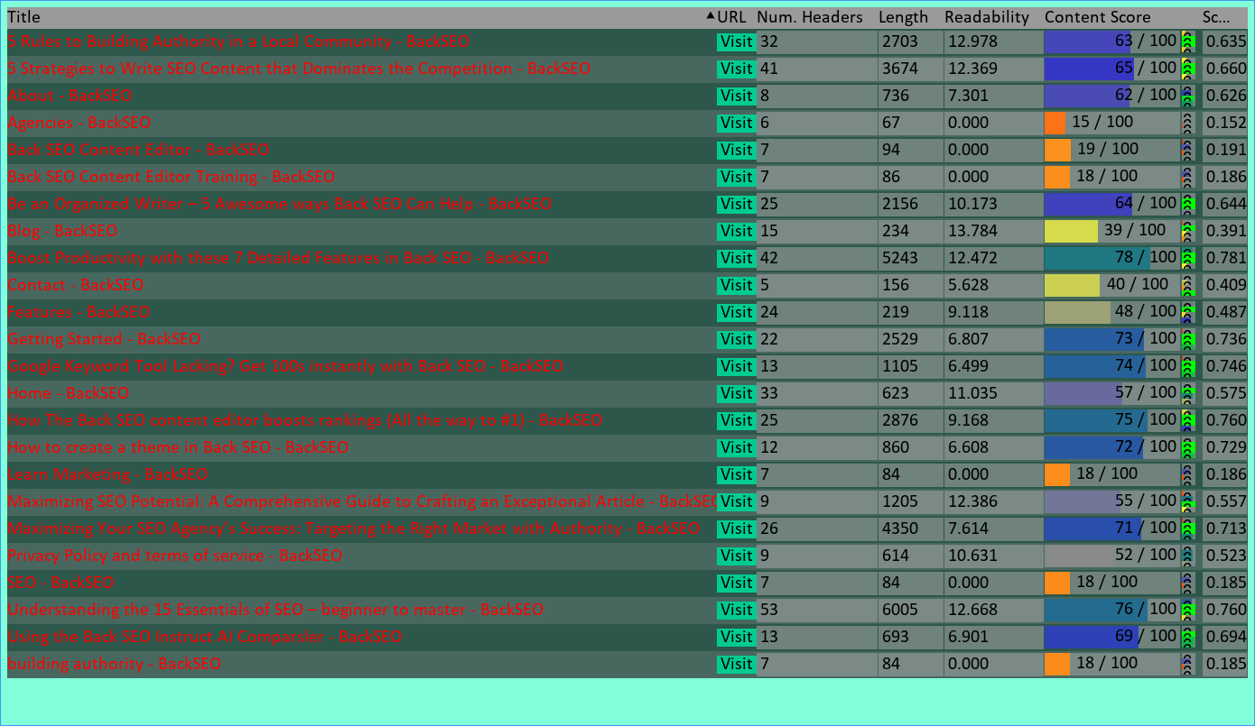

ppc - BackSEO

https://backseo.org/tag/ppc/
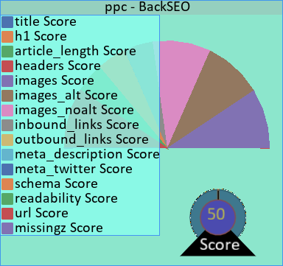 | No H1.  Meta description is too short or too long at 0 characters. (Rec: 130-160)  Title is too short at 13 characters.  Too many or too few headers. Recommended is 0.0525-0.42 headers.  The article is too short or too long at 21 words. Recommended is 300-5000 words.  The article is too short or too long at 21 words. Recommended is 1000-3000 words.  Needs a Twitter meta description

Details
Title | ppc - BackSEO
Num H1 | 0
Number of Headers | 4
Length | 21
Number of Images | 3
Number of Images with Alt Text | 3
Number of Images without Alt Text | 0
Number of Inbound Links | 13
Number of Outbound Links | 4
Meta Description Length | 0
Meta:Twitter | False
Readability | 0.0
Schema | True
URL | https://backseo.org/tag/ppc/

Getting Started - BackSEO

https://backseo.org/getting-started/
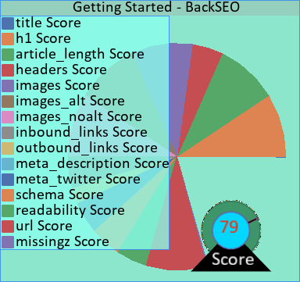 | Meta description is too short or too long at 287 characters. (Rec: 130-160)  Title is too short at 25 characters.

Details
Title | Getting Started - BackSEO
Num H1 | 1
Number of Headers | 22
Length | 2529
Number of Images | 16
Number of Images with Alt Text | 16
Number of Images without Alt Text | 0
Number of Inbound Links | 11
Number of Outbound Links | 6
Meta Description Length | 287
Meta:Twitter | True
Readability | 6.806745435016111
Schema | True
URL | https://backseo.org/getting-started/

Learn Marketing - BackSEO

https://backseo.org/category/learn/
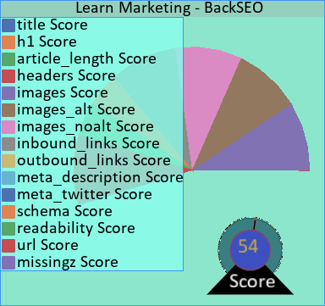 | No H1.  Meta description is too short or too long at 0 characters. (Rec: 130-160)  Title is too short at 25 characters.  Too many or too few headers. Recommended is 0.21-1.68 headers.  The article is too short or too long at 84 words. Recommended is 300-5000 words.  The article is too short or too long at 84 words. Recommended is 1000-3000 words.  Needs a Twitter meta description

Details
Title | Learn Marketing - BackSEO
Num H1 | 0
Number of Headers | 7
Length | 84
Number of Images | 3
Number of Images with Alt Text | 3
Number of Images without Alt Text | 0
Number of Inbound Links | 17
Number of Outbound Links | 4
Meta Description Length | 0
Meta:Twitter | False
Readability | 0.0
Schema | True
URL | https://backseo.org/category/learn/

Checkout - BackSEO

https://backseo.org/checkout/
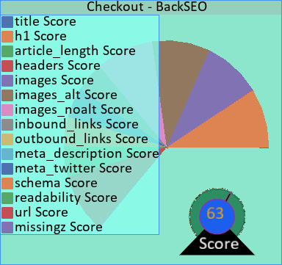 | Meta description is too short or too long at 0 characters. (Rec: 130-160)  Title is too short at 18 characters.  Too many or too few headers. Recommended is 0.0075-0.06 headers.  The article is too short or too long at 3 words. Recommended is 300-5000 words.  The article is too short or too long at 3 words. Recommended is 1000-3000 words.

Details
Title | Checkout - BackSEO
Num H1 | 1
Number of Headers | 4
Length | 3
Number of Images | 3
Number of Images with Alt Text | 3
Number of Images without Alt Text | 0
Number of Inbound Links | 11
Number of Outbound Links | 4
Meta Description Length | 0
Meta:Twitter | True
Readability | 0.0
Schema | True
URL | https://backseo.org/checkout/

Downloads - BackSEO

https://backseo.org/downloads/
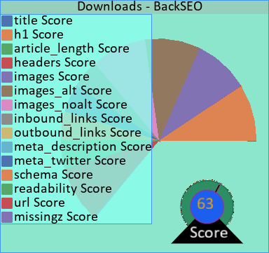 | Meta description is too short or too long at 0 characters. (Rec: 130-160)  Title is too short at 19 characters.  Too many or too few headers. Recommended is 0.03-0.24 headers.  The article is too short or too long at 12 words. Recommended is 300-5000 words.  The article is too short or too long at 12 words. Recommended is 1000-3000 words.

Details
Title | Downloads - BackSEO
Num H1 | 1
Number of Headers | 6
Length | 12
Number of Images | 4
Number of Images with Alt Text | 4
Number of Images without Alt Text | 0
Number of Inbound Links | 12
Number of Outbound Links | 4
Meta Description Length | 0
Meta:Twitter | True
Readability | 0.0
Schema | True
URL | https://backseo.org/downloads/

writing clients - BackSEO

https://backseo.org/tag/writing-clients/
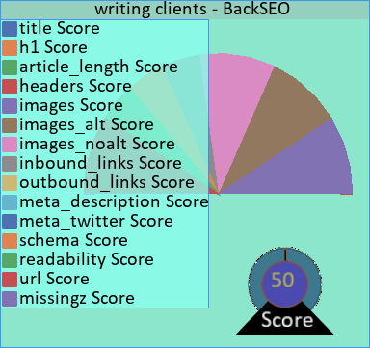 | No H1.  Meta description is too short or too long at 0 characters. (Rec: 130-160)  Title is too short at 25 characters.  Too many or too few headers. Recommended is 0.0625-0.5 headers.  The article is too short or too long at 25 words. Recommended is 300-5000 words.  The article is too short or too long at 25 words. Recommended is 1000-3000 words.  Needs a Twitter meta description

Details
Title | writing clients - BackSEO
Num H1 | 0
Number of Headers | 4
Length | 25
Number of Images | 3
Number of Images with Alt Text | 3
Number of Images without Alt Text | 0
Number of Inbound Links | 13
Number of Outbound Links | 4
Meta Description Length | 0
Meta:Twitter | False
Readability | 0.0
Schema | True
URL | https://backseo.org/tag/writing-clients/

Receipt - BackSEO

https://backseo.org/checkout/receipt/
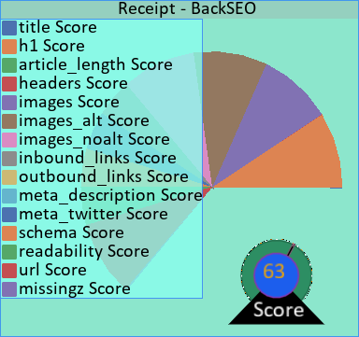 | Meta description is too short or too long at 0 characters. (Rec: 130-160)  Title is too short at 17 characters.  Too many or too few headers. Recommended is 0.01-0.08 headers.  The article is too short or too long at 4 words. Recommended is 300-5000 words.  The article is too short or too long at 4 words. Recommended is 1000-3000 words.

Details
Title | Receipt - BackSEO
Num H1 | 1
Number of Headers | 4
Length | 4
Number of Images | 3
Number of Images with Alt Text | 3
Number of Images without Alt Text | 0
Number of Inbound Links | 11
Number of Outbound Links | 4
Meta Description Length | 0
Meta:Twitter | True
Readability | 0.0
Schema | True
URL | https://backseo.org/checkout/receipt/

How to create a theme in Back SEO - BackSEO

https://backseo.org/how-to-create-a-theme-in-back-seo/
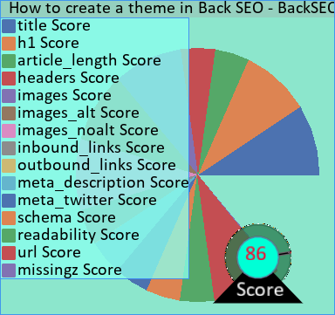 | The article is too short or too long at 860 words. Recommended is 1000-3000 words.

Details
Title | How to create a theme in Back SEO - BackSEO
Num H1 | 1
Number of Headers | 12
Length | 860
Number of Images | 8
Number of Images with Alt Text | 8
Number of Images without Alt Text | 0
Number of Inbound Links | 14
Number of Outbound Links | 4
Meta Description Length | 67
Meta:Twitter | True
Readability | 6.608425531914893
Schema | True
URL | https://backseo.org/how-to-create-a-theme-in-back-seo/

Back SEO Content Editor - BackSEO

https://backseo.org/tag/back-seo-content-editor/
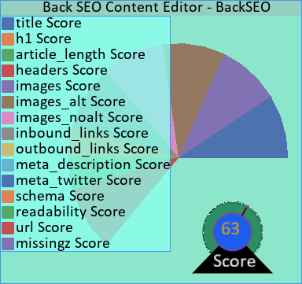 | No H1.  Meta description is too short or too long at 0 characters. (Rec: 130-160)  Too many or too few headers. Recommended is 0.235-1.88 headers.  The article is too short or too long at 94 words. Recommended is 300-5000 words.  The article is too short or too long at 94 words. Recommended is 1000-3000 words.  Needs a Twitter meta description

Details
Title | Back SEO Content Editor - BackSEO
Num H1 | 0
Number of Headers | 7
Length | 94
Number of Images | 3
Number of Images with Alt Text | 3
Number of Images without Alt Text | 0
Number of Inbound Links | 18
Number of Outbound Links | 4
Meta Description Length | 0
Meta:Twitter | False
Readability | 0.0
Schema | True
URL | https://backseo.org/tag/back-seo-content-editor/

Login - BackSEO

https://backseo.org/login/
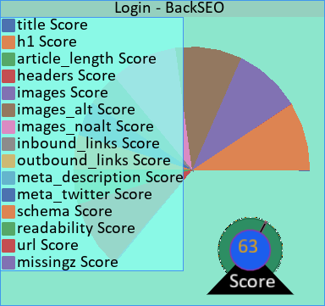 | Meta description is too short or too long at 10 characters. (Rec: 130-160)  Title is too short at 15 characters.  Too many or too few headers. Recommended is 0.005-0.04 headers.  The article is too short or too long at 2 words. Recommended is 300-5000 words.  The article is too short or too long at 2 words. Recommended is 1000-3000 words.

Details
Title | Login - BackSEO
Num H1 | 1
Number of Headers | 4
Length | 2
Number of Images | 3
Number of Images with Alt Text | 3
Number of Images without Alt Text | 0
Number of Inbound Links | 12
Number of Outbound Links | 4
Meta Description Length | 10
Meta:Twitter | True
Readability | 0.0
Schema | True
URL | https://backseo.org/login/

How The Back SEO content editor boosts rankings (All the way to #1) - BackSEO

https://backseo.org/back-seo-content-editor/
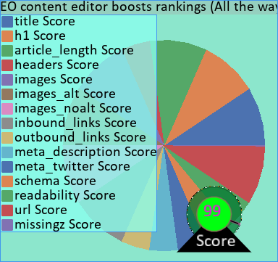

Details
Title | How The Back SEO content editor boosts rankings (All the way to #1) - BackSEO
Num H1 | 1
Number of Headers | 25
Length | 2876
Number of Images | 5
Number of Images with Alt Text | 5
Number of Images without Alt Text | 0
Number of Inbound Links | 17
Number of Outbound Links | 12
Meta Description Length | 102
Meta:Twitter | True
Readability | 9.167874213836473
Schema | True
URL | https://backseo.org/back-seo-content-editor/

Confirm Purchase - BackSEO

https://backseo.org/downloads/backseo-content-tool/
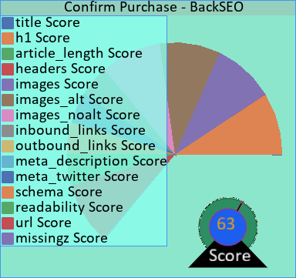 | Meta description is too short or too long at 0 characters. (Rec: 130-160)  Title is too short at 26 characters.  Too many or too few headers. Recommended is 0.065-0.52 headers.  The article is too short or too long at 26 words. Recommended is 300-5000 words.  The article is too short or too long at 26 words. Recommended is 1000-3000 words.

Details
Title | Confirm Purchase - BackSEO
Num H1 | 1
Number of Headers | 8
Length | 26
Number of Images | 4
Number of Images with Alt Text | 4
Number of Images without Alt Text | 0
Number of Inbound Links | 13
Number of Outbound Links | 4
Meta Description Length | 0
Meta:Twitter | True
Readability | 0.0
Schema | True
URL | https://backseo.org/downloads/backseo-content-tool/

building authority - BackSEO

https://backseo.org/tag/building-authority/
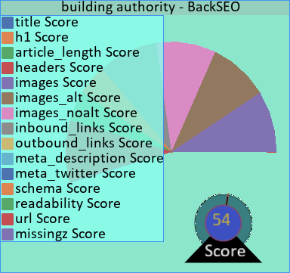 | No H1.  Meta description is too short or too long at 0 characters. (Rec: 130-160)  Title is too short at 28 characters.  Too many or too few headers. Recommended is 0.21-1.68 headers.  The article is too short or too long at 84 words. Recommended is 300-5000 words.  The article is too short or too long at 84 words. Recommended is 1000-3000 words.  Needs a Twitter meta description

Details
Title | building authority - BackSEO
Num H1 | 0
Number of Headers | 7
Length | 84
Number of Images | 3
Number of Images with Alt Text | 3
Number of Images without Alt Text | 0
Number of Inbound Links | 17
Number of Outbound Links | 4
Meta Description Length | 0
Meta:Twitter | False
Readability | 0.0
Schema | True
URL | https://backseo.org/tag/building-authority/

Features - BackSEO

https://backseo.org/features/
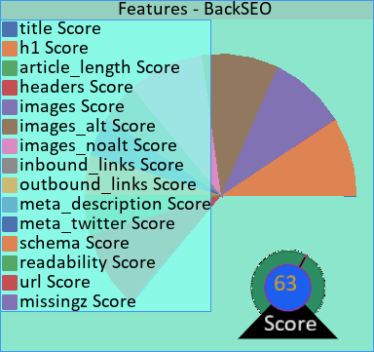 | Meta description is too short or too long at 336 characters. (Rec: 130-160)  Title is too short at 18 characters.  Too many or too few headers. Recommended is 0.5475-4.38 headers.  The article is too short or too long at 219 words. Recommended is 300-5000 words.  The article is too short or too long at 219 words. Recommended is 1000-3000 words.

Details
Title | Features - BackSEO
Num H1 | 1
Number of Headers | 24
Length | 219
Number of Images | 26
Number of Images with Alt Text | 26
Number of Images without Alt Text | 0
Number of Inbound Links | 13
Number of Outbound Links | 5
Meta Description Length | 336
Meta:Twitter | True
Readability | 9.118294573643407
Schema | True
URL | https://backseo.org/features/

Contact - BackSEO

https://backseo.org/contact-2/
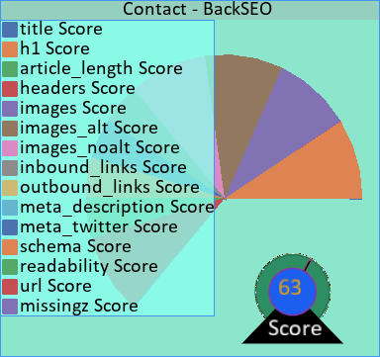 | Meta description is too short or too long at 288 characters. (Rec: 130-160)  Title is too short at 17 characters.  Too many or too few headers. Recommended is 0.39-3.12 headers.  The article is too short or too long at 156 words. Recommended is 300-5000 words.  The article is too short or too long at 156 words. Recommended is 1000-3000 words.

Details
Title | Contact - BackSEO
Num H1 | 1
Number of Headers | 5
Length | 156
Number of Images | 3
Number of Images with Alt Text | 3
Number of Images without Alt Text | 0
Number of Inbound Links | 12
Number of Outbound Links | 4
Meta Description Length | 288
Meta:Twitter | True
Readability | 5.627657142857142
Schema | True
URL | https://backseo.org/contact-2/

Privacy Policy and terms of service - BackSEO

https://backseo.org/privacy-policy/
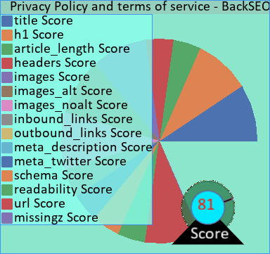 | Meta description is too short or too long at 355 characters. (Rec: 130-160)  The article is too short or too long at 614 words. Recommended is 1000-3000 words.

Details
Title | Privacy Policy and terms of service - BackSEO
Num H1 | 1
Number of Headers | 9
Length | 614
Number of Images | 3
Number of Images with Alt Text | 3
Number of Images without Alt Text | 0
Number of Inbound Links | 11
Number of Outbound Links | 4
Meta Description Length | 355
Meta:Twitter | True
Readability | 10.630817610062891
Schema | True
URL | https://backseo.org/privacy-policy/

5 Strategies to Write SEO Content that Dominates the Competition - BackSEO

https://backseo.org/5-strategies-to-write-seo-content/
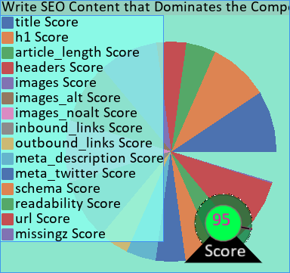 | The article is too short or too long at 3674 words. Recommended is 1000-3000 words.

Details
Title | 5 Strategies to Write SEO Content that Dominates the Competition - BackSEO
Num H1 | 1
Number of Headers | 41
Length | 3674
Number of Images | 6
Number of Images with Alt Text | 6
Number of Images without Alt Text | 0
Number of Inbound Links | 20
Number of Outbound Links | 24
Meta Description Length | 186
Meta:Twitter | True
Readability | 12.368761904761904
Schema | True
URL | https://backseo.org/5-strategies-to-write-seo-content/

Be an Organized Writer – 5 Awesome ways Back SEO Can Help - BackSEO

https://backseo.org/be-an-organized-writer-with-back-seo/
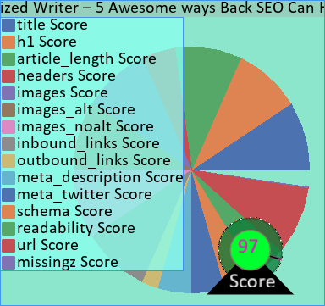

Details
Title | Be an Organized Writer – 5 Awesome ways Back SEO Can Help - BackSEO
Num H1 | 1
Number of Headers | 25
Length | 2156
Number of Images | 6
Number of Images with Alt Text | 6
Number of Images without Alt Text | 0
Number of Inbound Links | 17
Number of Outbound Links | 7
Meta Description Length | 93
Meta:Twitter | True
Readability | 10.172571428571427
Schema | True
URL | https://backseo.org/be-an-organized-writer-with-back-seo/

featured product - BackSEO

https://backseo.org/tag/featured-product/
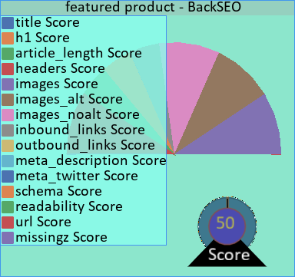 | No H1.  Meta description is too short or too long at 0 characters. (Rec: 130-160)  Title is too short at 26 characters.  Too many or too few headers. Recommended is 0.0675-0.54 headers.  The article is too short or too long at 27 words. Recommended is 300-5000 words.  The article is too short or too long at 27 words. Recommended is 1000-3000 words.  Needs a Twitter meta description

Details
Title | featured product - BackSEO
Num H1 | 0
Number of Headers | 4
Length | 27
Number of Images | 3
Number of Images with Alt Text | 3
Number of Images without Alt Text | 0
Number of Inbound Links | 13
Number of Outbound Links | 4
Meta Description Length | 0
Meta:Twitter | False
Readability | 0.0
Schema | True
URL | https://backseo.org/tag/featured-product/

Order History - BackSEO

https://backseo.org/checkout/order-history/
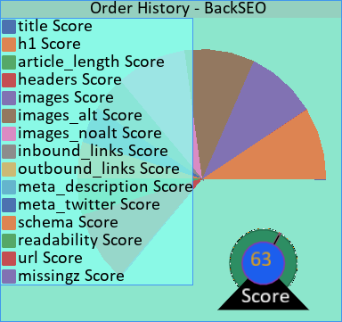 | Meta description is too short or too long at 0 characters. (Rec: 130-160)  Title is too short at 23 characters.  Too many or too few headers. Recommended is 0.0-0.0 headers.  The article is too short or too long at 0 words. Recommended is 300-5000 words.  The article is too short or too long at 0 words. Recommended is 1000-3000 words.

Details
Title | Order History - BackSEO
Num H1 | 1
Number of Headers | 4
Length | 0
Number of Images | 3
Number of Images with Alt Text | 3
Number of Images without Alt Text | 0
Number of Inbound Links | 11
Number of Outbound Links | 4
Meta Description Length | 0
Meta:Twitter | True
Readability | 0.0
Schema | True
URL | https://backseo.org/checkout/order-history/

writing - BackSEO

https://backseo.org/tag/writing/
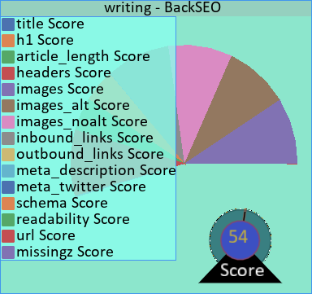 | No H1.  Meta description is too short or too long at 0 characters. (Rec: 130-160)  Title is too short at 17 characters.  Too many or too few headers. Recommended is 0.115-0.92 headers.  The article is too short or too long at 46 words. Recommended is 300-5000 words.  The article is too short or too long at 46 words. Recommended is 1000-3000 words.  Needs a Twitter meta description

Details
Title | writing - BackSEO
Num H1 | 0
Number of Headers | 5
Length | 46
Number of Images | 3
Number of Images with Alt Text | 3
Number of Images without Alt Text | 0
Number of Inbound Links | 16
Number of Outbound Links | 4
Meta Description Length | 0
Meta:Twitter | False
Readability | 0.0
Schema | True
URL | https://backseo.org/tag/writing/

Maximizing Your SEO Agency’s Success: Targeting the Right Market with Authority - BackSEO

https://backseo.org/maximizing-seo-agency-success/
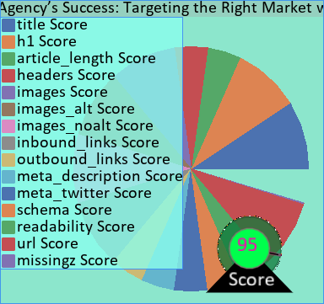 | The article is too short or too long at 4350 words. Recommended is 1000-3000 words.

Details
Title | Maximizing Your SEO Agency’s Success: Targeting the Right Market with Authority - BackSEO
Num H1 | 1
Number of Headers | 26
Length | 4350
Number of Images | 5
Number of Images with Alt Text | 5
Number of Images without Alt Text | 0
Number of Inbound Links | 17
Number of Outbound Links | 13
Meta Description Length | 167
Meta:Twitter | True
Readability | 7.61409688013136
Schema | True
URL | https://backseo.org/maximizing-seo-agency-success/

keyword tool - BackSEO

https://backseo.org/tag/keyword-tool/
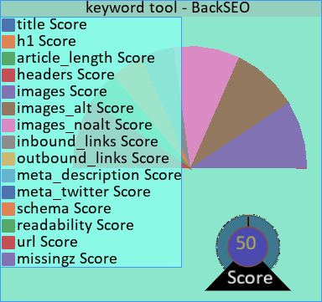 | No H1.  Meta description is too short or too long at 0 characters. (Rec: 130-160)  Title is too short at 22 characters.  Too many or too few headers. Recommended is 0.105-0.84 headers.  The article is too short or too long at 42 words. Recommended is 300-5000 words.  The article is too short or too long at 42 words. Recommended is 1000-3000 words.  Needs a Twitter meta description

Details
Title | keyword tool - BackSEO
Num H1 | 0
Number of Headers | 5
Length | 42
Number of Images | 3
Number of Images with Alt Text | 3
Number of Images without Alt Text | 0
Number of Inbound Links | 15
Number of Outbound Links | 4
Meta Description Length | 0
Meta:Twitter | False
Readability | 0.0
Schema | True
URL | https://backseo.org/tag/keyword-tool/

idea generator - BackSEO

https://backseo.org/tag/idea-generator/
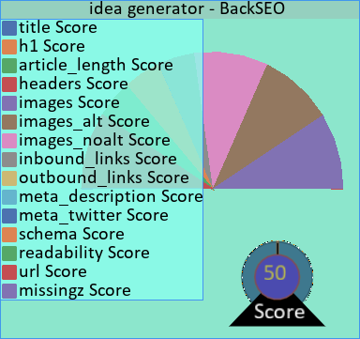 | No H1.  Meta description is too short or too long at 0 characters. (Rec: 130-160)  Title is too short at 24 characters.  Too many or too few headers. Recommended is 0.0525-0.42 headers.  The article is too short or too long at 21 words. Recommended is 300-5000 words.  The article is too short or too long at 21 words. Recommended is 1000-3000 words.  Needs a Twitter meta description

Details
Title | idea generator - BackSEO
Num H1 | 0
Number of Headers | 4
Length | 21
Number of Images | 3
Number of Images with Alt Text | 3
Number of Images without Alt Text | 0
Number of Inbound Links | 13
Number of Outbound Links | 4
Meta Description Length | 0
Meta:Twitter | False
Readability | 0.0
Schema | True
URL | https://backseo.org/tag/idea-generator/

Back SEO Content Editor Training - BackSEO

https://backseo.org/category/back-seo-training/
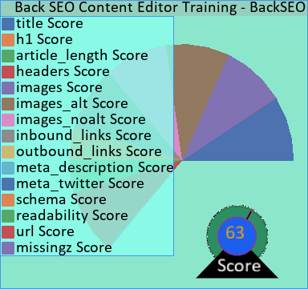 | No H1.  Meta description is too short or too long at 0 characters. (Rec: 130-160)  Too many or too few headers. Recommended is 0.215-1.72 headers.  The article is too short or too long at 86 words. Recommended is 300-5000 words.  The article is too short or too long at 86 words. Recommended is 1000-3000 words.  Needs a Twitter meta description

Details
Title | Back SEO Content Editor Training - BackSEO
Num H1 | 0
Number of Headers | 7
Length | 86
Number of Images | 3
Number of Images with Alt Text | 3
Number of Images without Alt Text | 0
Number of Inbound Links | 16
Number of Outbound Links | 4
Meta Description Length | 0
Meta:Twitter | False
Readability | 0.0
Schema | True
URL | https://backseo.org/category/back-seo-training/

Boost Productivity with these 7 Detailed Features in Back SEO - BackSEO

https://backseo.org/7-ways-content-editors-boost-productivity/
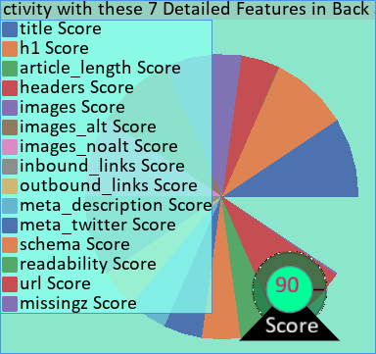 | The article is too short or too long at 5243 words. Recommended is 300-5000 words.  The article is too short or too long at 5243 words. Recommended is 1000-3000 words.

Details
Title | Boost Productivity with these 7 Detailed Features in Back SEO - BackSEO
Num H1 | 1
Number of Headers | 42
Length | 5243
Number of Images | 11
Number of Images with Alt Text | 11
Number of Images without Alt Text | 0
Number of Inbound Links | 17
Number of Outbound Links | 19
Meta Description Length | 123
Meta:Twitter | True
Readability | 12.472491842692772
Schema | True
URL | https://backseo.org/7-ways-content-editors-boost-productivity/

5 Rules to Building Authority in a Local Community - BackSEO

https://backseo.org/5-rules-to-building-authority-in-a-local-community/
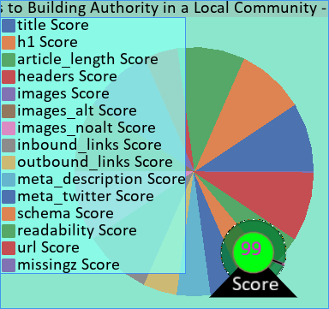

Details
Title | 5 Rules to Building Authority in a Local Community - BackSEO
Num H1 | 1
Number of Headers | 32
Length | 2703
Number of Images | 4
Number of Images with Alt Text | 4
Number of Images without Alt Text | 0
Number of Inbound Links | 17
Number of Outbound Links | 15
Meta Description Length | 174
Meta:Twitter | True
Readability | 12.978305308275637
Schema | True
URL | https://backseo.org/5-rules-to-building-authority-in-a-local-community/

Maximizing SEO Potential: A Comprehensive Guide to Crafting an Exceptional Article - BackSEO

https://backseo.org/maximizing-seo-potential-a-comprehensive-guide-to-crafting-an-exceptional-article/
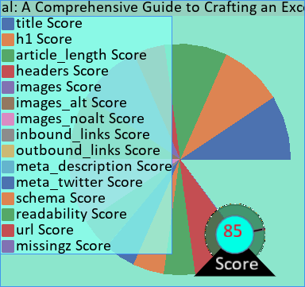 | Meta description is too short or too long at 354 characters. (Rec: 130-160)

Details
Title | Maximizing SEO Potential: A Comprehensive Guide to Crafting an Exceptional Article - BackSEO
Num H1 | 1
Number of Headers | 9
Length | 1205
Number of Images | 3
Number of Images with Alt Text | 3
Number of Images without Alt Text | 0
Number of Inbound Links | 14
Number of Outbound Links | 4
Meta Description Length | 354
Meta:Twitter | True
Readability | 12.386328310864393
Schema | True
URL | https://backseo.org/maximizing-seo-potential-a-comprehensive-guide-to-crafting-an-exceptional-article/

SEO - BackSEO

https://backseo.org/category/seo/
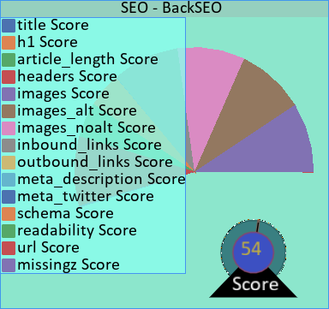 | No H1.  Meta description is too short or too long at 0 characters. (Rec: 130-160)  Title is too short at 13 characters.  Too many or too few headers. Recommended is 0.21-1.68 headers.  The article is too short or too long at 84 words. Recommended is 300-5000 words.  The article is too short or too long at 84 words. Recommended is 1000-3000 words.  Needs a Twitter meta description

Details
Title | SEO - BackSEO
Num H1 | 0
Number of Headers | 7
Length | 84
Number of Images | 3
Number of Images with Alt Text | 3
Number of Images without Alt Text | 0
Number of Inbound Links | 17
Number of Outbound Links | 4
Meta Description Length | 0
Meta:Twitter | False
Readability | 0.0
Schema | True
URL | https://backseo.org/category/seo/

Transaction Failed - BackSEO

https://backseo.org/checkout/transaction-failed/
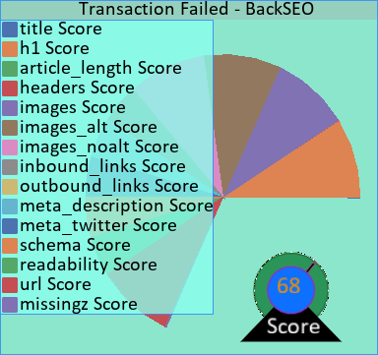 | Title is too short at 28 characters.  Too many or too few headers. Recommended is 0.0225-0.18 headers.  The article is too short or too long at 9 words. Recommended is 300-5000 words.  The article is too short or too long at 9 words. Recommended is 1000-3000 words.

Details
Title | Transaction Failed - BackSEO
Num H1 | 1
Number of Headers | 4
Length | 9
Number of Images | 3
Number of Images with Alt Text | 3
Number of Images without Alt Text | 0
Number of Inbound Links | 11
Number of Outbound Links | 4
Meta Description Length | 66
Meta:Twitter | True
Readability | 0.0
Schema | True
URL | https://backseo.org/checkout/transaction-failed/

Understanding the 15 Essentials of SEO – beginner to master - BackSEO

https://backseo.org/understanding-the-essentials-of-seo/
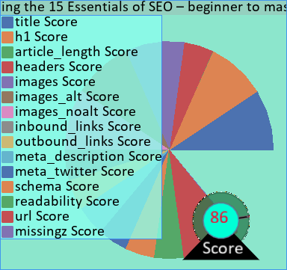 | The article is too short or too long at 6005 words. Recommended is 300-5000 words.  The article is too short or too long at 6005 words. Recommended is 1000-3000 words.

Details
Title | Understanding the 15 Essentials of SEO – beginner to master - BackSEO
Num H1 | 1
Number of Headers | 53
Length | 6005
Number of Images | 9
Number of Images with Alt Text | 9
Number of Images without Alt Text | 0
Number of Inbound Links | 13
Number of Outbound Links | 10
Meta Description Length | 87
Meta:Twitter | True
Readability | 12.667764293025293
Schema | True
URL | https://backseo.org/understanding-the-essentials-of-seo/

Comparison - BackSEO

https://backseo.org/tag/comparison/
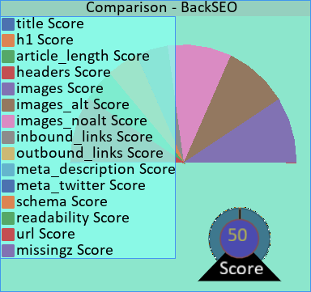 | No H1.  Meta description is too short or too long at 0 characters. (Rec: 130-160)  Title is too short at 20 characters.  Too many or too few headers. Recommended is 0.0675-0.54 headers.  The article is too short or too long at 27 words. Recommended is 300-5000 words.  The article is too short or too long at 27 words. Recommended is 1000-3000 words.  Needs a Twitter meta description

Details
Title | Comparison - BackSEO
Num H1 | 0
Number of Headers | 4
Length | 27
Number of Images | 3
Number of Images with Alt Text | 3
Number of Images without Alt Text | 0
Number of Inbound Links | 13
Number of Outbound Links | 4
Meta Description Length | 0
Meta:Twitter | False
Readability | 0.0
Schema | True
URL | https://backseo.org/tag/comparison/

Updates - BackSEO

https://backseo.org/updates/
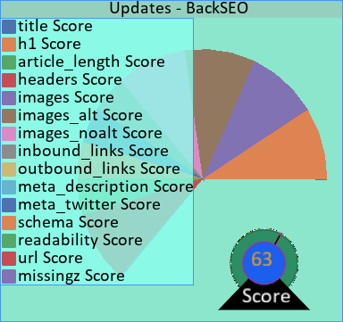 | Meta description is too short or too long at 358 characters. (Rec: 130-160)  Title is too short at 17 characters.  Too many or too few headers. Recommended is 0.07-0.56 headers.  The article is too short or too long at 28 words. Recommended is 300-5000 words.  The article is too short or too long at 28 words. Recommended is 1000-3000 words.

Details
Title | Updates - BackSEO
Num H1 | 1
Number of Headers | 4
Length | 28
Number of Images | 3
Number of Images with Alt Text | 3
Number of Images without Alt Text | 0
Number of Inbound Links | 11
Number of Outbound Links | 4
Meta Description Length | 358
Meta:Twitter | True
Readability | 0.0
Schema | True
URL | https://backseo.org/updates/

seo writing - BackSEO

https://backseo.org/tag/seo-writing/
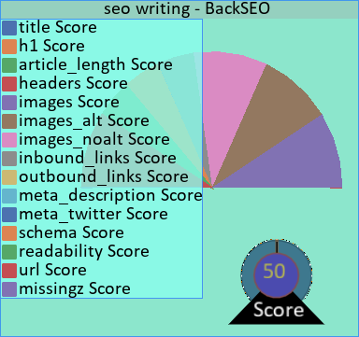 | No H1.  Meta description is too short or too long at 0 characters. (Rec: 130-160)  Title is too short at 21 characters.  Too many or too few headers. Recommended is 0.0525-0.42 headers.  The article is too short or too long at 21 words. Recommended is 300-5000 words.  The article is too short or too long at 21 words. Recommended is 1000-3000 words.  Needs a Twitter meta description

Details
Title | seo writing - BackSEO
Num H1 | 0
Number of Headers | 4
Length | 21
Number of Images | 3
Number of Images with Alt Text | 3
Number of Images without Alt Text | 0
Number of Inbound Links | 14
Number of Outbound Links | 4
Meta Description Length | 0
Meta:Twitter | False
Readability | 0.0
Schema | True
URL | https://backseo.org/tag/seo-writing/

write seo content - BackSEO

https://backseo.org/tag/write-seo-content/
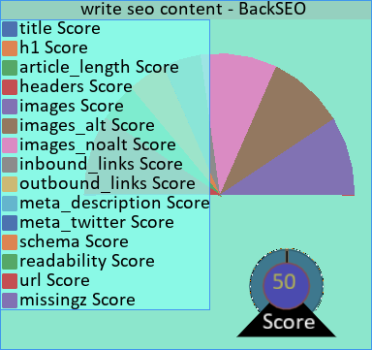 | No H1.  Meta description is too short or too long at 0 characters. (Rec: 130-160)  Title is too short at 27 characters.  Too many or too few headers. Recommended is 0.0525-0.42 headers.  The article is too short or too long at 21 words. Recommended is 300-5000 words.  The article is too short or too long at 21 words. Recommended is 1000-3000 words.  Needs a Twitter meta description

Details
Title | write seo content - BackSEO
Num H1 | 0
Number of Headers | 4
Length | 21
Number of Images | 3
Number of Images with Alt Text | 3
Number of Images without Alt Text | 0
Number of Inbound Links | 14
Number of Outbound Links | 4
Meta Description Length | 0
Meta:Twitter | False
Readability | 0.0
Schema | True
URL | https://backseo.org/tag/write-seo-content/

Using the Back SEO Instruct AI Comparsler - BackSEO

https://backseo.org/using-the-back-seo-instruct-ai-comparsler/
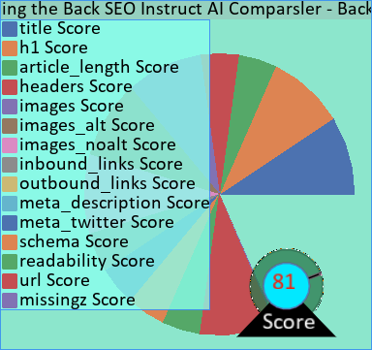 | Meta description is too short or too long at 324 characters. (Rec: 130-160)  The article is too short or too long at 693 words. Recommended is 1000-3000 words.

Details
Title | Using the Back SEO Instruct AI Comparsler - BackSEO
Num H1 | 1
Number of Headers | 13
Length | 693
Number of Images | 6
Number of Images with Alt Text | 6
Number of Images without Alt Text | 0
Number of Inbound Links | 13
Number of Outbound Links | 4
Meta Description Length | 324
Meta:Twitter | True
Readability | 6.900514138817478
Schema | True
URL | https://backseo.org/using-the-back-seo-instruct-ai-comparsler/

Home - BackSEO

https://backseo.org/
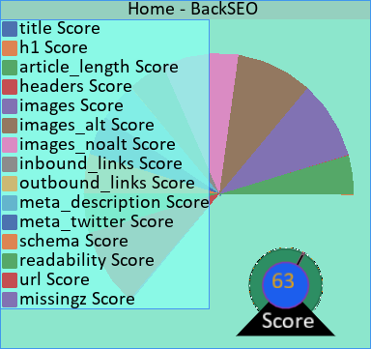 | No H1.  Title is too short at 14 characters.  Too many or too few headers. Recommended is 1.5575-12.46 headers.  The article is too short or too long at 623 words. Recommended is 1000-3000 words.

Details
Title | Home - BackSEO
Num H1 | 0
Number of Headers | 33
Length | 623
Number of Images | 10
Number of Images with Alt Text | 10
Number of Images without Alt Text | 0
Number of Inbound Links | 12
Number of Outbound Links | 4
Meta Description Length | 152
Meta:Twitter | True
Readability | 11.034851485148511
Schema | True
URL | https://backseo.org/

Back SEO Agencies - BackSEO

https://backseo.org/downloads/back-seo-agencies/
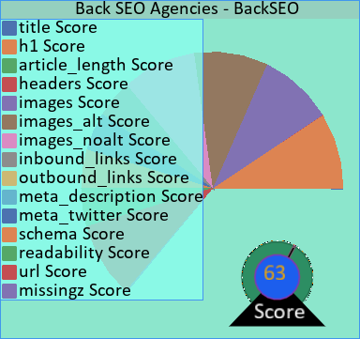 | Meta description is too short or too long at 0 characters. (Rec: 130-160)  Title is too short at 27 characters.  Too many or too few headers. Recommended is 0.06-0.48 headers.  The article is too short or too long at 24 words. Recommended is 300-5000 words.  The article is too short or too long at 24 words. Recommended is 1000-3000 words.

Details
Title | Back SEO Agencies - BackSEO
Num H1 | 1
Number of Headers | 5
Length | 24
Number of Images | 3
Number of Images with Alt Text | 3
Number of Images without Alt Text | 0
Number of Inbound Links | 12
Number of Outbound Links | 4
Meta Description Length | 0
Meta:Twitter | True
Readability | 0.0
Schema | True
URL | https://backseo.org/downloads/back-seo-agencies/

seo agency - BackSEO

https://backseo.org/tag/seo-agency/
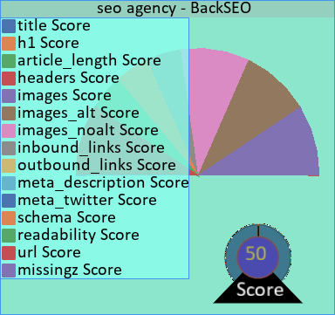 | No H1.  Meta description is too short or too long at 0 characters. (Rec: 130-160)  Title is too short at 20 characters.  Too many or too few headers. Recommended is 0.0575-0.46 headers.  The article is too short or too long at 23 words. Recommended is 300-5000 words.  The article is too short or too long at 23 words. Recommended is 1000-3000 words.  Needs a Twitter meta description

Details
Title | seo agency - BackSEO
Num H1 | 0
Number of Headers | 4
Length | 23
Number of Images | 3
Number of Images with Alt Text | 3
Number of Images without Alt Text | 0
Number of Inbound Links | 13
Number of Outbound Links | 4
Meta Description Length | 0
Meta:Twitter | False
Readability | 0.0
Schema | True
URL | https://backseo.org/tag/seo-agency/

Google Keyword Tool Lacking? Get 100s instantly with Back SEO - BackSEO

https://backseo.org/google-keyword-tool-lacking-get-100s-instantly-with-back-seo/
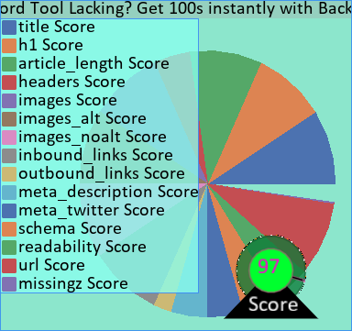

Details
Title | Google Keyword Tool Lacking? Get 100s instantly with Back SEO - BackSEO
Num H1 | 1
Number of Headers | 13
Length | 1105
Number of Images | 11
Number of Images with Alt Text | 11
Number of Images without Alt Text | 0
Number of Inbound Links | 17
Number of Outbound Links | 6
Meta Description Length | 170
Meta:Twitter | True
Readability | 6.498588421887391
Schema | True
URL | https://backseo.org/google-keyword-tool-lacking-get-100s-instantly-with-back-seo/

Blog - BackSEO

https://backseo.org/blog/
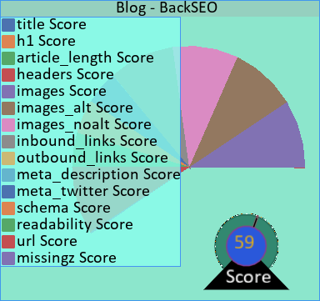 | No H1.  Meta description is too short or too long at 0 characters. (Rec: 130-160)  Title is too short at 14 characters.  Too many or too few headers. Recommended is 0.585-4.68 headers.  The article is too short or too long at 234 words. Recommended is 300-5000 words.  The article is too short or too long at 234 words. Recommended is 1000-3000 words.

Details
Title | Blog - BackSEO
Num H1 | 0
Number of Headers | 15
Length | 234
Number of Images | 3
Number of Images with Alt Text | 3
Number of Images without Alt Text | 0
Number of Inbound Links | 26
Number of Outbound Links | 4
Meta Description Length | 0
Meta:Twitter | True
Readability | 13.783557312252963
Schema | True
URL | https://backseo.org/blog/

About - BackSEO

https://backseo.org/about/
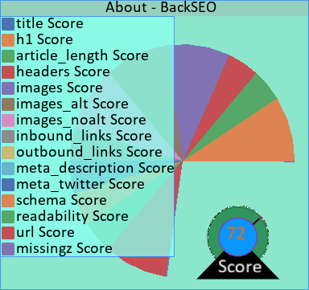 | Meta description is too short or too long at 299 characters. (Rec: 130-160)  Title is too short at 15 characters.  The article is too short or too long at 736 words. Recommended is 1000-3000 words.

Details
Title | About - BackSEO
Num H1 | 1
Number of Headers | 8
Length | 736
Number of Images | 3
Number of Images with Alt Text | 3
Number of Images without Alt Text | 0
Number of Inbound Links | 11
Number of Outbound Links | 4
Meta Description Length | 299
Meta:Twitter | True
Readability | 7.300964467005077
Schema | True
URL | https://backseo.org/about/

community - BackSEO

https://backseo.org/tag/community/
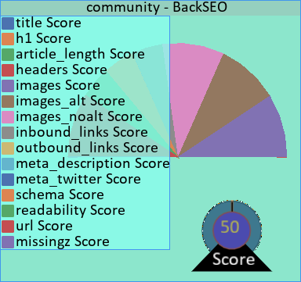 | No H1.  Meta description is too short or too long at 0 characters. (Rec: 130-160)  Title is too short at 19 characters.  Too many or too few headers. Recommended is 0.0475-0.38 headers.  The article is too short or too long at 19 words. Recommended is 300-5000 words.  The article is too short or too long at 19 words. Recommended is 1000-3000 words.  Needs a Twitter meta description

Details
Title | community - BackSEO
Num H1 | 0
Number of Headers | 4
Length | 19
Number of Images | 3
Number of Images with Alt Text | 3
Number of Images without Alt Text | 0
Number of Inbound Links | 13
Number of Outbound Links | 4
Meta Description Length | 0
Meta:Twitter | False
Readability | 0.0
Schema | True
URL | https://backseo.org/tag/community/

Agencies - BackSEO

https://backseo.org/agencies/
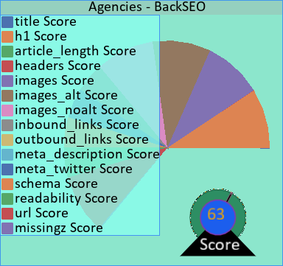 | Meta description is too short or too long at 290 characters. (Rec: 130-160)  Title is too short at 18 characters.  Too many or too few headers. Recommended is 0.1675-1.34 headers.  The article is too short or too long at 67 words. Recommended is 300-5000 words.  The article is too short or too long at 67 words. Recommended is 1000-3000 words.

Details
Title | Agencies - BackSEO
Num H1 | 1
Number of Headers | 6
Length | 67
Number of Images | 3
Number of Images with Alt Text | 3
Number of Images without Alt Text | 0
Number of Inbound Links | 11
Number of Outbound Links | 5
Meta Description Length | 290
Meta:Twitter | True
Readability | 0.0
Schema | True
URL | https://backseo.org/agencies/

Themes - BackSEO

https://backseo.org/themes/
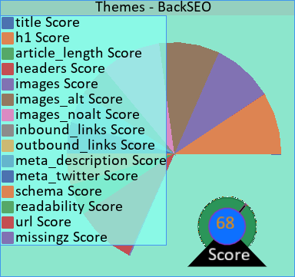 | Title is too short at 16 characters.  Too many or too few headers. Recommended is 0.02-0.16 headers.  The article is too short or too long at 8 words. Recommended is 300-5000 words.  The article is too short or too long at 8 words. Recommended is 1000-3000 words.

Details
Title | Themes - BackSEO
Num H1 | 1
Number of Headers | 4
Length | 8
Number of Images | 6
Number of Images with Alt Text | 6
Number of Images without Alt Text | 0
Number of Inbound Links | 11
Number of Outbound Links | 5
Meta Description Length | 47
Meta:Twitter | True
Readability | 0.0
Schema | True
URL | https://backseo.org/themes/

local seo - BackSEO

https://backseo.org/tag/local-seo/
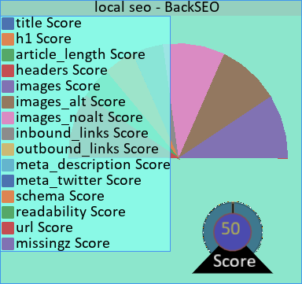 | No H1.  Meta description is too short or too long at 0 characters. (Rec: 130-160)  Title is too short at 19 characters.  Too many or too few headers. Recommended is 0.105-0.84 headers.  The article is too short or too long at 42 words. Recommended is 300-5000 words.  The article is too short or too long at 42 words. Recommended is 1000-3000 words.  Needs a Twitter meta description

Details
Title | local seo - BackSEO
Num H1 | 0
Number of Headers | 5
Length | 42
Number of Images | 3
Number of Images with Alt Text | 3
Number of Images without Alt Text | 0
Number of Inbound Links | 14
Number of Outbound Links | 4
Meta Description Length | 0
Meta:Twitter | False
Readability | 0.0
Schema | True
URL | https://backseo.org/tag/local-seo/

Sitemap - BackSEO

https://backseo.org/sitemap/
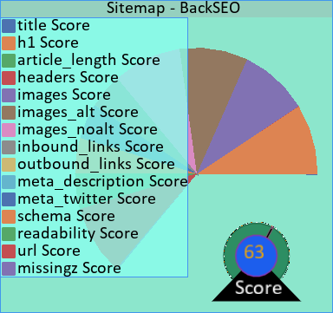 | Meta description is too short or too long at 0 characters. (Rec: 130-160)  Title is too short at 17 characters.  Too many or too few headers. Recommended is 0.0-0.0 headers.  The article is too short or too long at 0 words. Recommended is 300-5000 words.  The article is too short or too long at 0 words. Recommended is 1000-3000 words.

Details
Title | Sitemap - BackSEO
Num H1 | 1
Number of Headers | 4
Length | 0
Number of Images | 3
Number of Images with Alt Text | 3
Number of Images without Alt Text | 0
Number of Inbound Links | 11
Number of Outbound Links | 4
Meta Description Length | 0
Meta:Twitter | True
Readability | 0.0
Schema | True
URL | https://backseo.org/sitemap/

Confirmation - BackSEO

https://backseo.org/checkout/confirmation/
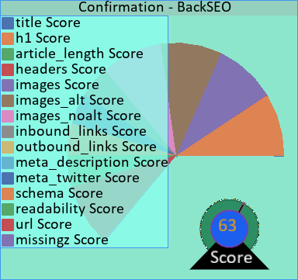 | Meta description is too short or too long at 28 characters. (Rec: 130-160)  Title is too short at 22 characters.  Too many or too few headers. Recommended is 0.025-0.2 headers.  The article is too short or too long at 10 words. Recommended is 300-5000 words.  The article is too short or too long at 10 words. Recommended is 1000-3000 words.

Details
Title | Confirmation - BackSEO
Num H1 | 1
Number of Headers | 4
Length | 10
Number of Images | 3
Number of Images with Alt Text | 3
Number of Images without Alt Text | 0
Number of Inbound Links | 11
Number of Outbound Links | 4
Meta Description Length | 28
Meta:Twitter | True
Readability | 0.0
Schema | True
URL | https://backseo.org/checkout/confirmation/

