SEO Report

SEO Report Subtitle
Company Name
1234 Main St. City, State 12345
123-456-7890
example@company.org
example.org

Table of Contents
Table of Contents
Table of Contents 1

Local SEO Audit (1 mi.)
Back SEO Marketing Software

Back SEO Marketing Software

Node Distance: 1
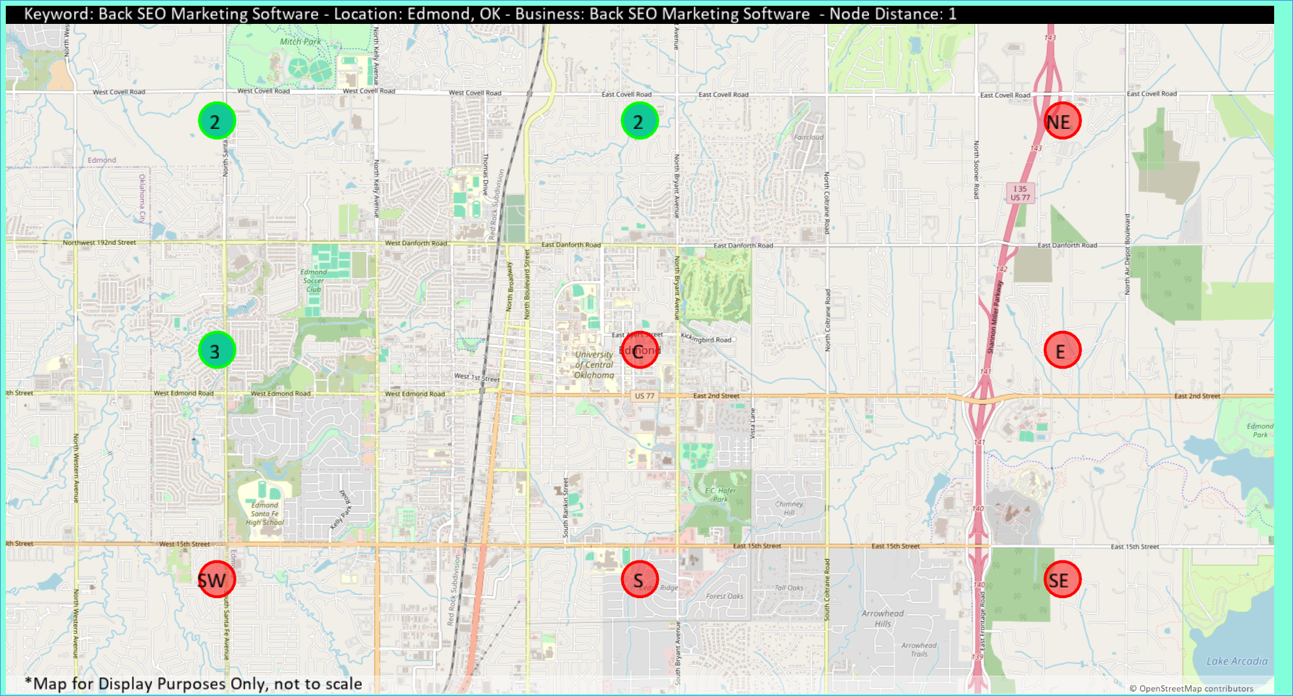
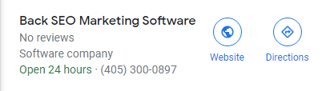
Direction | Rank 1 | Rank 2 | Rank 3
NW | 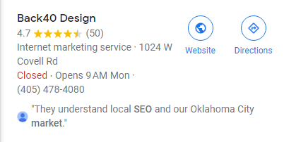 |  | 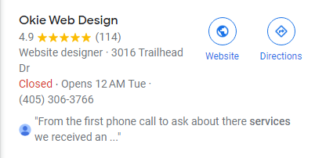
N
NE
W | 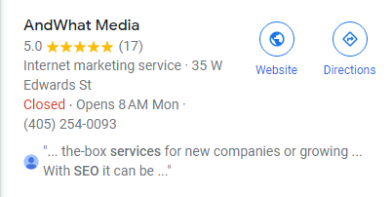
C
E
SW
S
SE

Local SEO Audit (15 mi.)
Back SEO Marketing Software

Back SEO Marketing Software

Node Distance: 15
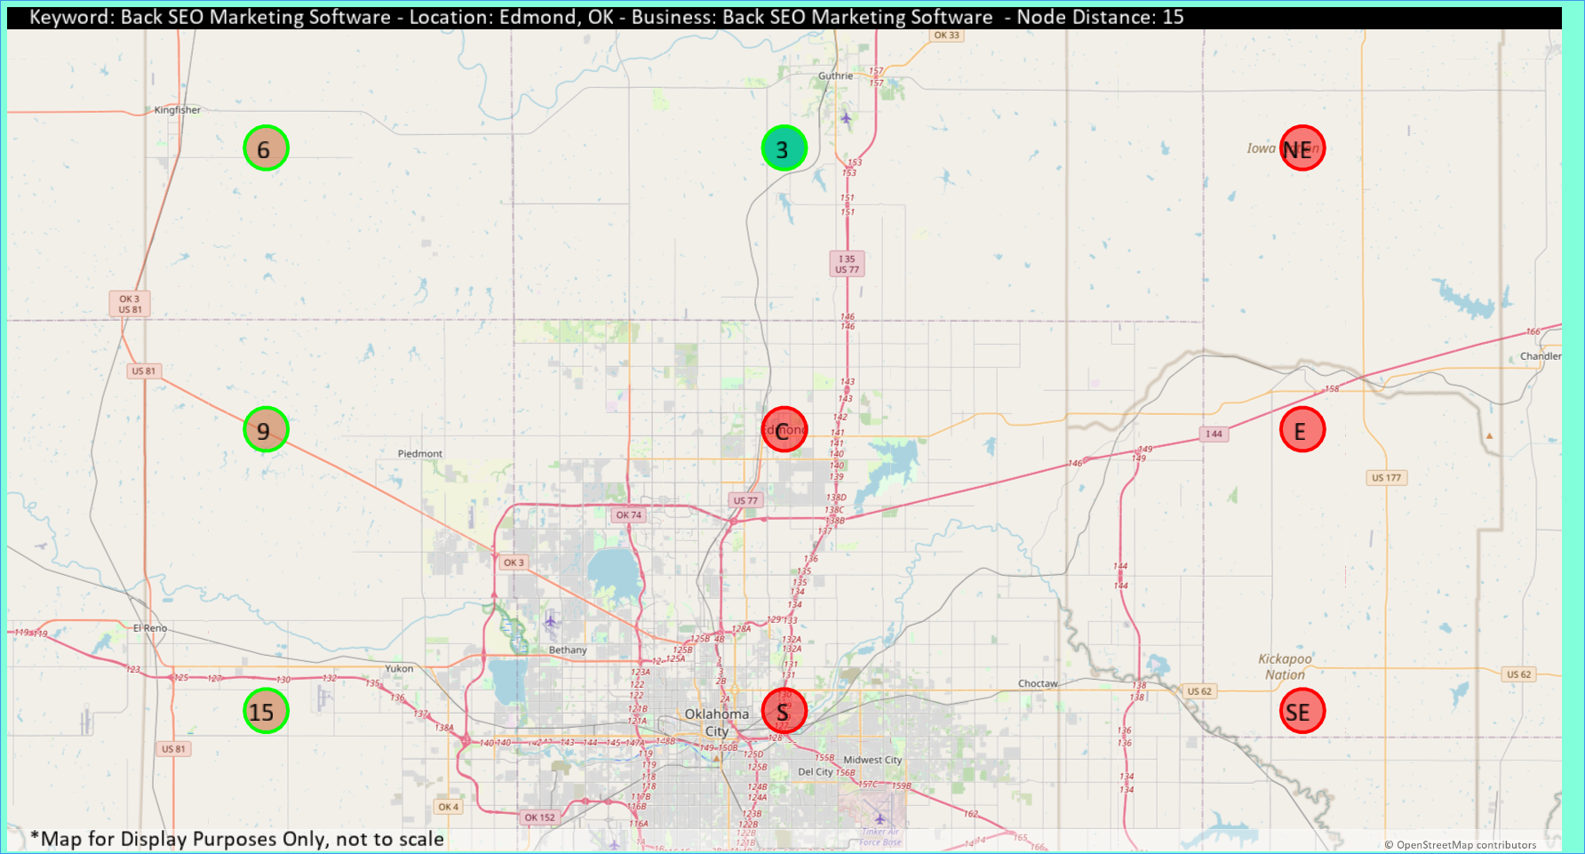
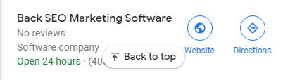
Direction | Rank 1 | Rank 2 | Rank 3
NW | 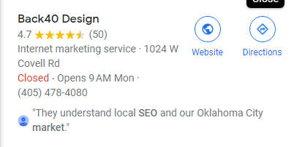 |  | 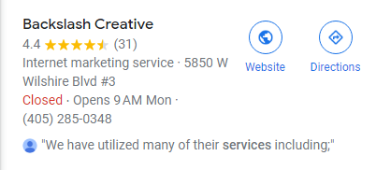
N
NE
W
C
E
SW |  | 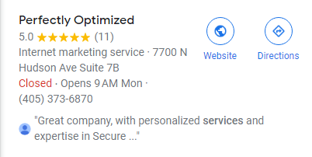 | 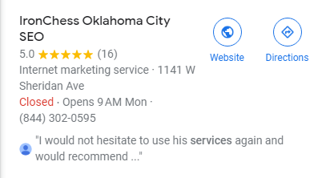
S |  | 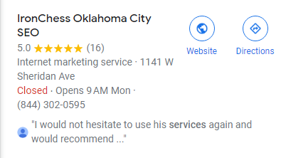 | 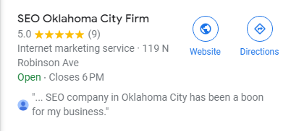
SE

Search Audit
Back SEO Marketing Software
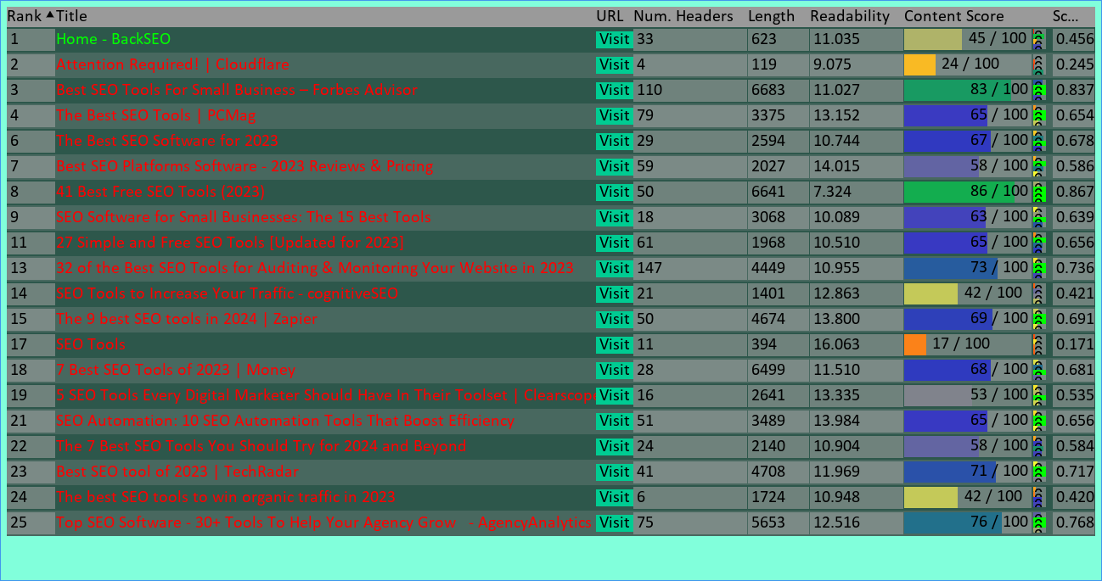

Search Audit
Back SEO Marketing Software in Edmond, OK
